OS : Debian
Latest Version : V 11 (Bullseye)
Features : Stable,Version Stay for Long time,ideal for Servers ,Rolling release option,support many pc Architectures ,DVD CD and ISO available ,java friendly
Most Stable Version :V 11 (Bullseye)

OS : CentOS
Latest Version : Centos 8.5-2111
Features : Very Stable,Free,Open Source ,Run by the community , Same like Red hat but free and no support
Most Stable Version :CentOs 8

OS : RedHat
Latest Version : RHEL 8.5
Features : Run by RedHat Org, Not free, long releases ,Stable ,easy configuration,contains development tools
Most Stable Version :RHEL 8

OS : Ubuntu
Latest Version : Ubuntu 20.04.3 LTS
Features : Ubuntu is free and an open-source Os, Secure ,it Runs without install ,Customizable,Resource Friendly ,can be used for PC ,can be used for servers too
Most Stable Version : Ubuntu Server 20.04

OS : Fedora
Latest Version : fedora 35
Features : Fedora OS offers many architectures ,very reliable and stable Os,it has unique security features ,provides a very powerful firewall,easy to use ,large community,actively developed
Most Stable Version : fedora 35

OS : suse
Latest Version : SLES 15 SP3
Features : Centralized administration and deployment tools,Support for network boot and diskless operation,Simplified installation process for installing and configuring the point of service environment,YaST graphical user interface for creating images
Most Stable Version : SLES 15 SP2

OS : kali Linux
Latest Version : 2021.4a
Features Full customisation of Kali ISOs,Live USB Boot,Kali Undercover,The industry standard,free
Most Stable Version : 2021.4a

Commands
cd -> used to navigate and go back to home
cd .. -> used to go back
cd / -> used to go back
cd /home/dev -> absolute path
cd dev -> relative path
ls -> is used to look at files in current directory
ls -l -> is used to look files with details
mkdir -> is used to create a directory
pwd ->is used to see current path
cat -> used to read file
whoami -> used to see who using the system
exit -> is used to exit
history -> is used to look at all the commands we used
sudo -i -> is used to switch to root user
mkdir name1 name2 -> can create multiple directories
touch -> is used to create a files like txt
touch test{1..4} -> is used to create a files with name test1 test2 test3 test4
cp filename path -> is used to copy file and paste it at given path
cp -r -> is used to copy directory
cp --help -> is used to see all the options available
mv filename path -> is used to move file to a path
mv oldname newname -> is used to change name of the file
mv -r -> is used to move directory
mv *.txt -> is used to move all files with .txt
rm filename -> is used to remove the file
rm -r -> is used to remove the directory
rm *.txt -> is used to remove all files with .txt
rm rf -> is used to force delete anything
file filename -> is used to see file type
mkdir -p /home/opt/dev/test -> used to create entire path if not exist before
ln -s /path/file /home/links -> is used to create link to directly access file content
ls -lt -> sort the list of items in directory
ls -ltr -> to reverse sort
grep firewall anaconda-ks.cfg -> used for the searching word firewall in cfg file
grep -i -> used to remove case sensitive
grep -i firewall * -> used to search all the files in directory
grep -iR firewall * -> is used to even look in directory inside a directory
grep -v ,grep vi -> is used to look for all other words except it
less filname.cfg -> used to read and search (/word)the content in file
more filename -> is used to read file and also show percentage of the file
head -10 filename.cfg -> is used to read first 10 lines of the file
tail -2 filename.cfg -> i used to see last 2 lines of the files
tail -f message -> is used to see dynamic log
cut -d: -f1 /etc/passwd -> used to see all the values in field 1 (first column)
awk -F':' '{print $1}' /etc/passwd -> advanced search
sed 's/Tarun/Tar/g' file.txt -> to change name but won't be changes in file
sed -i 's/Tarun/tar/g' file.txt -> to actually make changes in file
echo -> is used to print text
uptime > /temp/sysinfo.txt -> redirecting the output into a file sysinfo.txt
date >> /temp/sysinfo.txt -> used to append the output to sysinfo.txt
free -m -> used to see memory details
df -h ->hard disk details
date -> used to check date
path /dev/null -> its like a black hole anything redirected to this path will be gone
freee -m 2> /temp/error.txt -> is used to redirect the errors
date -m &> /temp/error.txt -> is used to redirect anything
wc -l file.txt -> is used to count no of lines in file
ls | wc-l -> used to count the files in directory
ls | grep host -> used to search the files
find /etc -name host * -> to find filename
id vagrant -> is used to look user details
useradd name -> used to add user
groupadd name -> used to add group
usermod -aG groupname username -> to assign user to group(secondary group)
usermod -ag groupname username -> to assign user to group(primary group)
passwd username -> to add password for user
su - username -> to login as a user
last -> to see login list
who -> to see current login user
userdel -r username -> to delete the user
groupdel -r groupname -> to delete group
chown user:group /opt/devopsdir -> to select the user
ls -ld /opt/devopsdir -> to see user permissions
chmod 640 /opt/devopsdir -> to change xwr for the file(numeric)
chmod rw- /opt/devopsdir -> to change xwr for the file (char)
visudo -> used to edit the sudo to an user
cd /etc/sudoers.d/ -> we can cp the exist file and change the sudo(for group use %group name )
Yum install vim -y -> for installing vim editor
Manual package install
We can't install this using yum
Go to google and type tree rpm
Click rpmfind.net
Look for centos 7.9 version since i'm using this
Copy the link by right clicking it
Go to vm root user
Packages like tree ,httpd
Package Commands

curl link -o link name ->to install
rpm -ivh -> command to install in human readable format
rpm -qa -> will list all the rpm
rpm -e rpm name -> to erase the rpm
cd /etc/yum.repos.d/ -> in this directory repositories will be there
yum search httpd -> to search for a packages
yum remove httpd -> to remove the packages
yum install wget
yum update -> it will upgrade all packages
yum reinstall package -> to reinstall
Services will be running in servers we can start and stop those services
systemctl status httpd -> used to look service status
systemctl start httpd -> used to start the service
systemctl restart httpd -> used to restart
systemctl reload service -> used to restart
sudo reboot -> will reboot the vm
systemctl enable httpd -> used to auto start the service when we restart to start the vm
systemctl is-active or is-enabled httpd -> used to check if active or not or enabled or not
Cat /etc/systemd/system/multi-user.target.wants/httpd.service
top -> is like task manager in windows(ps aux or ps -ef also same)
kill processNo -> used to stop process
Kill -9 processNo -> used to stop force
To kill all child processes
Ps -ef | grep httpd | grep -v ‘grep’ |awk ‘{print $2}’ | xargs kill -9
cd /var/log/ -> to look at logs
tar czvf jenkines_06122020.tar.gz path of file -> c-create z-compress v-verbos f-file to archive the file
tar xzvf jenkines_06122020.tar.gz where to save it-> to extract the file
yum install zip unzip -y -> is used to install zip and unzip
zip -r zipfilename.zip file -> used to zip the file
unzip filename -> to unzip the file
UBUNTU COMMANDS
adduser -> to add a user
export EDITOR=vim -> to add vim editor
wget link -> to get package file
dpkg -i tree(filename.deb) -> to install the package
dpkg -l -> to list debian packages
dpkg -r filename.deb -> to uninstall the package
apt install package -> same like yum can do search reinstall remove
apt upgrade -> to upgrade the packages
apt purge package -> used to remove package and also its data(configuration files )

VAGRANT COMMANDS
vagrant global-status -> used to see details about vms (vagrant global-status --prune) to remove unwanted info and run this command again
vagrant status -> used to see status of vms
ls -a -> used to see all files even hidden (touch .file ) use “.” to create the hidden files
We can edit vagrant file by notepad ++ and Inside vagrant file we can edit cpu ram or ips
# vb.memory = "1024"
vb.cpus=2 -> used to set no of cpus
cd /vagrant/ -> in vm if we search this the directory will be same in vagrant it is synch directory
Where you can put ur vm data and you can access that data in your windows pc that way you can backup your data if ur vm get corrupt
Touch bash.sh -> to create a bash file
To change synch directory path go to vagrant file edit and change config windows path that will be on left user (\\) as a path for windows path
config.vm.synced_folder "../data", "/vagrant_data"

Provisioning is running a script when creating a vm so anything written between this shell will be executed provisioning will only work first time install if you want to execute them in already installed vm use (vagrant reload --provision)

config.vm.provision "shell", inline: <<-SHELL
yum install vim -y
mkdir -p /etc/test
SHELL
HOSTING A WEBSITE IN LINUX
Go to tooplate.com and download a html code
Then create a new folder and get vagrant file and vagrant up it
Install unzip wget httpd packages
Go type ifconfig or ip addr show
Then select private or public ip
Pate it on chrome to see default centos page
cd /var/www/html/ -> this is where you should put your html files in linux
Go to that path and create vim index.html
Write something and save
systemctl restart httpd
Now check that private ip page you will see the text
Now go back to tooplate.com and hit f12 and go to network and click the download button of html page then u see the download link in network copy it
wget copied link -> to download the html file
unzip file .zip
Move this files to /var/www/html/
then restart the httpd and check ur private address
Vola you just created a server
WORDPRESS IN UBUNTU
Create a new ubuntu vm with private and public network enables
Go to https://ubuntu.com/tutorials/install-and-configure-wordpress#2-install-dependencies
Install all the required packages
cd /srv/www/wordpress/ -> here you can see all wordpress files
Then go to link and follow the configure apache for word
cd /etc/apache2/sites-enabled/ -> to check what are enables sites
At page 3 replace password with what u have set

AUTOMATE THE WEBSITE CREATION
We will use vagrant provisioning to automate the entire process this is called IAAC (Infrastructure as a code )
Just go to vagrant file and edit with notepad ++ change network configs put the commands instead of manually creating for every site we can just automate by changing wget link and uzip names
config.vm.provision "shell", inline: <<-SHELL
yum install httpd wget unzip -y
systemctl start httpd
systemctl enable httpd
cd /tmp/
wget https://www.tooplate.com/zip-templates/2119_gymso_fitness.zip
unzip -o 2119_gymso_fitness.zip
cp -r 2119_gymso_fitness/* /var/www/html/
systemctl restart httpd
SHELL
Go to https://www.vagrantup.com/docs and select getting started tutorials to see all vagrant commands

Multi vm vagrant file
Go to https://www.vagrantup.com/docs/multi-machine and copy this code
Vagrant.configure("2") do |config|
config.vm.provision "shell", inline: "echo Hello"

config.vm.define "web" do |web|
web01.vm.box = ""vmname
end

config.vm.define "db" do |db|
db01.vm.box = "vmname"
end
End
For detailed info go to c/work/Devops udemy and multi vms see the file

VPROFILE PROJECT
Copy the git code url
Go to git bash
git clone url -> used to clone the repository
git checkout branch_name -> to check the branches
vagrant plugin install vagrant-hostmanager -> used to connect all vms in multivms to same host
vagrant ssh vmname ->for accessing multi vms
cat /etc/hosts -> to see host names
ping vmname -> used to ping vms in same host
To make a variable permanent create a variable DATABASE_PASS=’admin123’
vi /etc/profile -> pase this variable at bottom
source /etc/profile -> to make it permanent
mysql -u root -p -> to login to root of mariadb
show databases; -> used to see databases
use databasename; -> to switch to that database
Show tables; -> used to see tables
ss -tunlp | grep port -> used to check the ports
rabbitmqctl add_user name passwd -> to create a user in rabbitmq
rabbitmqctl set_user_tags username tagname -> used to give a tag for user
vi /etc/hostname -> to change host name
hostname chnaged_name -> to confirm and restart
hostname -> to check hostname

BASH SCRIPTING
vim name.sh -> to create a script file
In side script start with #! /bin/bash
Variablename =”string” -> used to store value in variable
$variablename -> used to access that variable
$1 -$9 used to pass command line argument
vim test.sh
In test.sh
echo “first arg”
echo $1
echo “second arg”
echo $2
Before execute change the chmod +x filename
Now to pass the values
Give path and scriptname
test.sh hello
test.sh world

DevOps (visualpath.in)

$0 -> shows name of the script
$#-> how many arguments are passed to bash script
$@ -> all the arguments passed
$? -> the exist status of most recent process if it works output will be 0 else some no
$$ -> process of current script
$USER $HOSTNAME $SECONDS $RANDOM $LINENO
“In this $variable” -> in double quotes variable works
‘ in this $variable”-> in single quotes variable doesn't work
“In this \variable”-> when we use \ the special character will be ignored
time=`uptime` -> it will take the output and store it in variable
time =$(uptime) -> this do same thing too
export variable name -> used to export the variable to child shell which mean inside scripts
ls -a -> used to see hidden files
.bashrc -> if u vi .bashrc and put variable there it will work even after re login for single user
vim /etc/profile -> if u put variable in this it will be available for all users
read variable -> used to take input for that variable
read -p username: variable -> used to show message before taking input and store the value in variable
read -sp password: variable -> to hide user input
:se nu -> used in vim editor to give line nos
/word -> used in vim to look for a word

CONDITIONAL STATEMENTS
If [ $num -gt 100 ]
then
echo “we are in ture condition “
else
echo “we are in else condition”
fi
grep -ic name -> used to count no of times it occurred
gt ,eq,lt -> greater than equal to less than
If [ condition ]
then
Code
elif [ condition ]
then
code
else
code
fi
! -> used as not (!)
-n string ->if length of string is greater than zero
-z string -> true if length of string is zero
= -> equal to
!= -> not equal to
-d file -> file exist and its a directory
-e file -> file exist
-r file -> file exist and read permission is granted
-w file -> file exist and write permission is granted
-x file -> file exist and execute permission is granted
s file -> file exist and its size is greater than zero
0 is true in bash scripting and non 0 is false
cd /var/run/ -> here the process running will have a pid
crontab -e -> here we have to set path of our script and we have to give time and everything
Min Hour Date Month DayOfWeek
30 20 * * 1-5 /path of script &>> /var/log/monit.log
sleep no-> used to make execution stop for that many seconds
LOOPS
for var1 in java .net python .ruby
do
echo “$var1”
done

counter=0
while [ $counter -lt 5 ]
do
echo “value of counter is $counter“
counter=$(( $counter + 1))
done
true and false also works

Remote access among multi vms
First create a multi vms
now give host names for each vm
vim /etc/hosts -> here add ip and hostname
From this vm use
ssh vagrant@web01 -> to login to a vm from this vm
now login to each centos vm and add user named devops
And also give user sudo permissions
For ubuntu we can’t login directly from vm so we have to manually open it and go to
vim /etc/ssh/sshd_config
:su nu -> to set serial no
/password-> used to search for the world in vim
Now find the password authentication and change it to yes and do systemctl restart ssh
Now you can login into the ubuntu from vms using password
Now also create user devops in ubuntu
Now try using ssh devops@web01 uptime
This will get the task done without even entering to the particular vm
ls .ssh/ -> here keys and locks will be stored to access use ls -a
ssh-keygen -> is used to create a key based login
ssh-copy-id devops@web01 -> used to put the lock into vms and use key to access them
scp filename devops@web01:/tmp/ -> used to push file from one vm to another vm

The communication between two or more network interface is called computer network
OSI(Open system interconnection) is model of communication developed by ISO

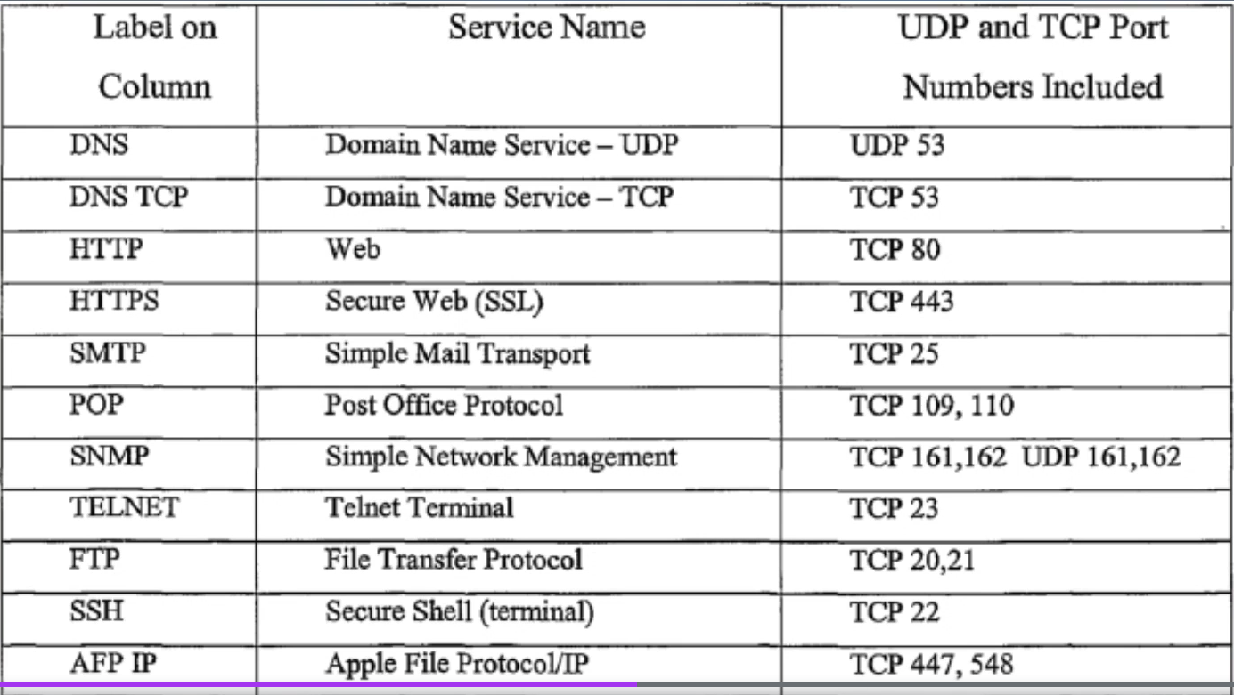

NETWORK COMMANDS
ping ip -> to ping to that ip
vi /etc/hosts -> inside (192.168.10.12 (ip) name) this is used to create a name for an ip you can ping with that name
tracert www.google.in -> shows all the routes it takes to reach google server used to see latency
netstat -antp -> used to see all ports and processes that are using them
ss -tunlp -> same as above
nmap -y -> is used to install commands (it is illegal in some countries so use for troubleshooting purpose only)
nmap localhosts -> used to see opened ports
nmap ip or name -> to see what ports are open in other vms
dig www.google.in -> it shows the ip address of the website
nslookup www.google.in -> it shows same as dig
route -n -> it used to show gateways
arp -> is used to look and add it to kernel table
mtr www.google.com -> show all the hops in live
telnet ip port -> used to connect to that ip via port
Ifconfig

